Christian Clark

CIS123

Chapter 7 Review

1. A)6A B)EA C)FD D)A9
2. A)9A B)6A C)A9 D)3A
3. AX=2200h DX = 0002h
4. AX=0306h
5. EAX=00012340h EDX=00000000h
6. IntegerOverflow
7. 0066h
8. Crashes and gives Integer Overflow error
9. 0004080C10140000h

Algorithm Workbench:

1. SHL EAX,4
2. SHR EAX,2
3. SHLD DX,AX,1

CONTINUED ON NEXT PAGE

1. ByteArrayShiftRight.asm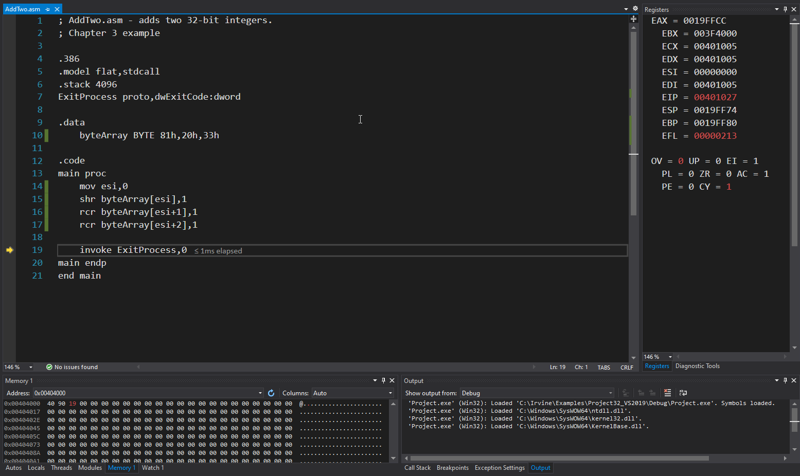

9. NegativeMul.asm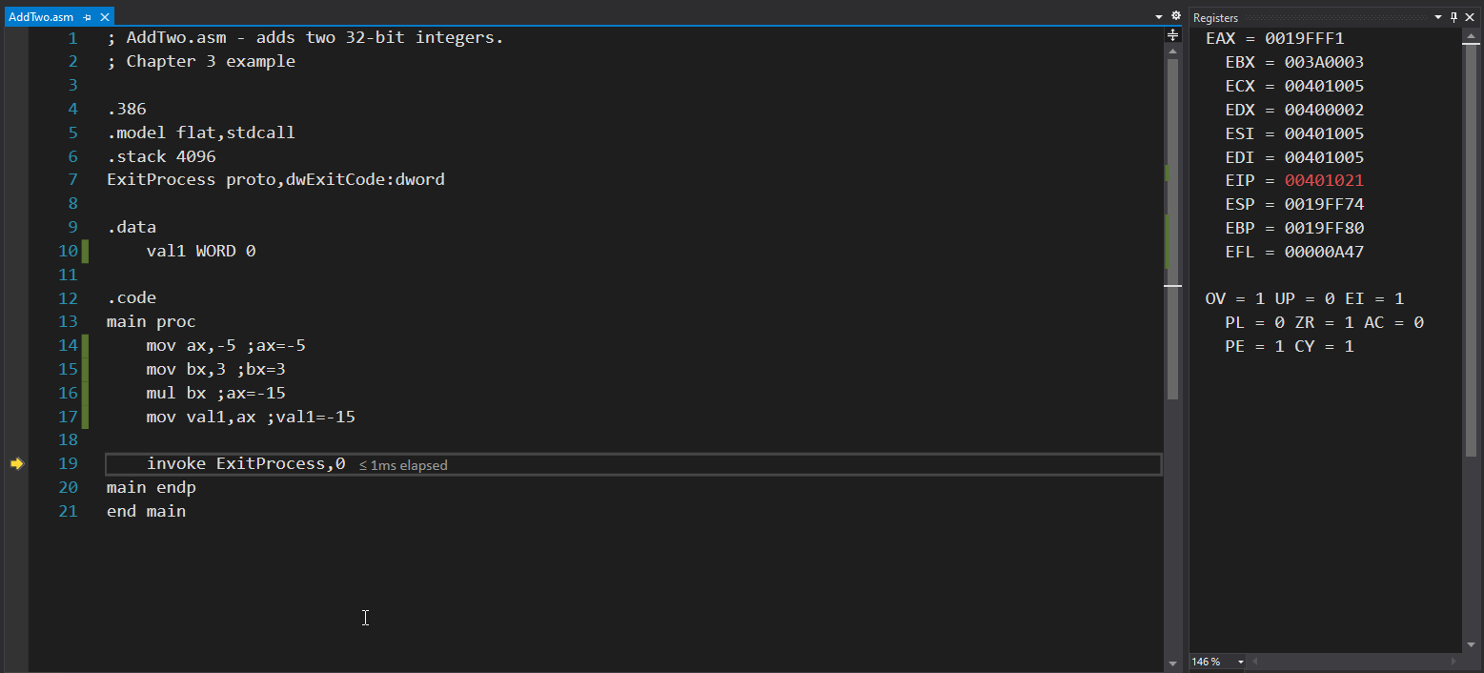

10. SignedDiv.asm modified code from page 264 in the book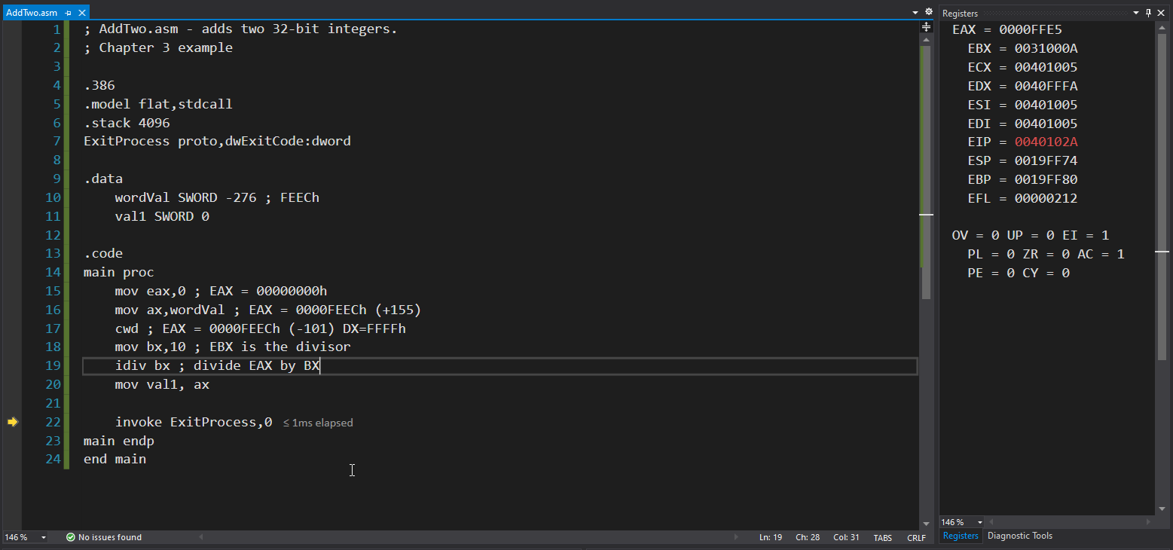

11. MULandDIV.asm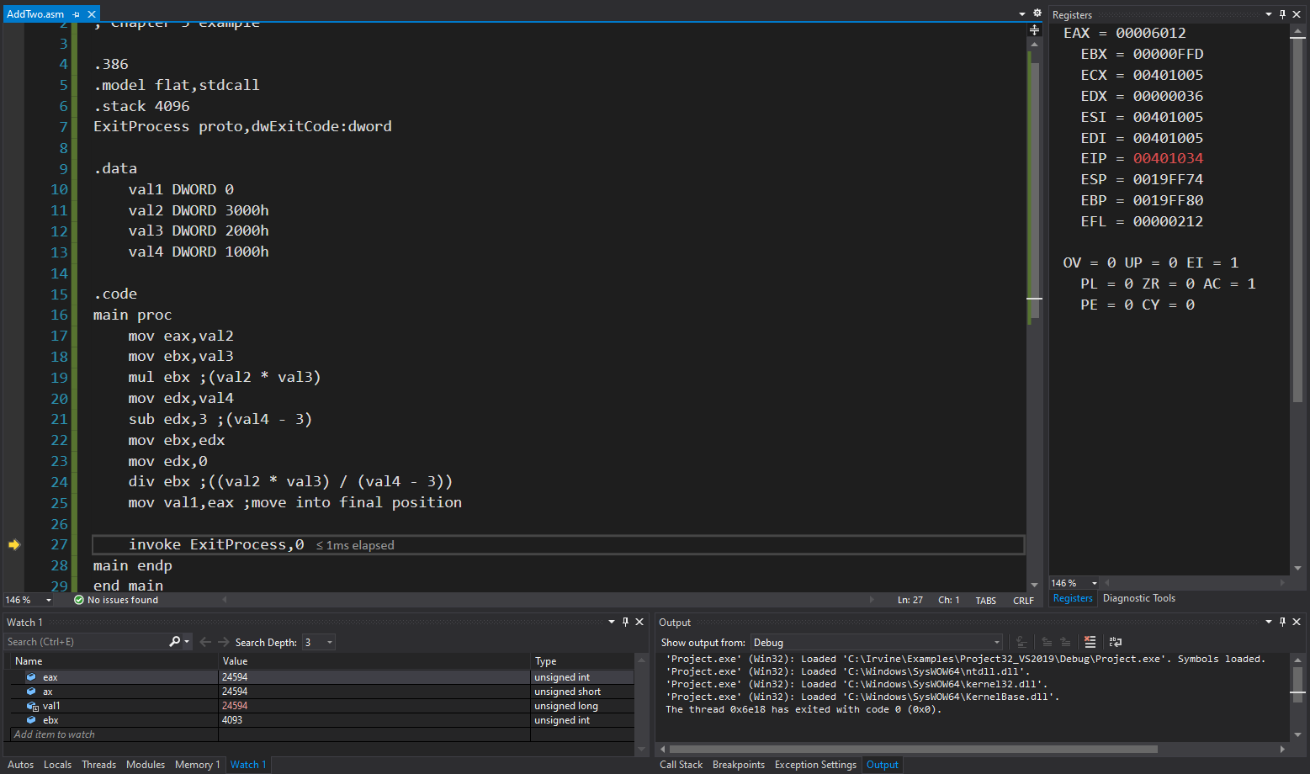

12. AlgorithmWorkbench12.asm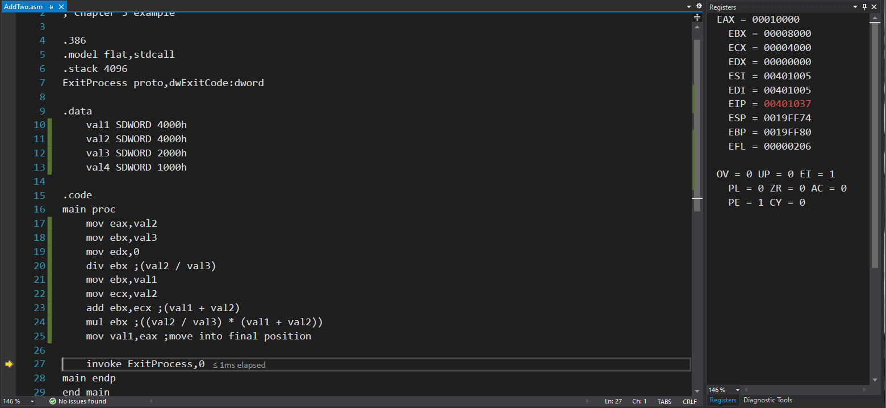

GCDFinder.asm has the GCD Programming excersize \*\*\*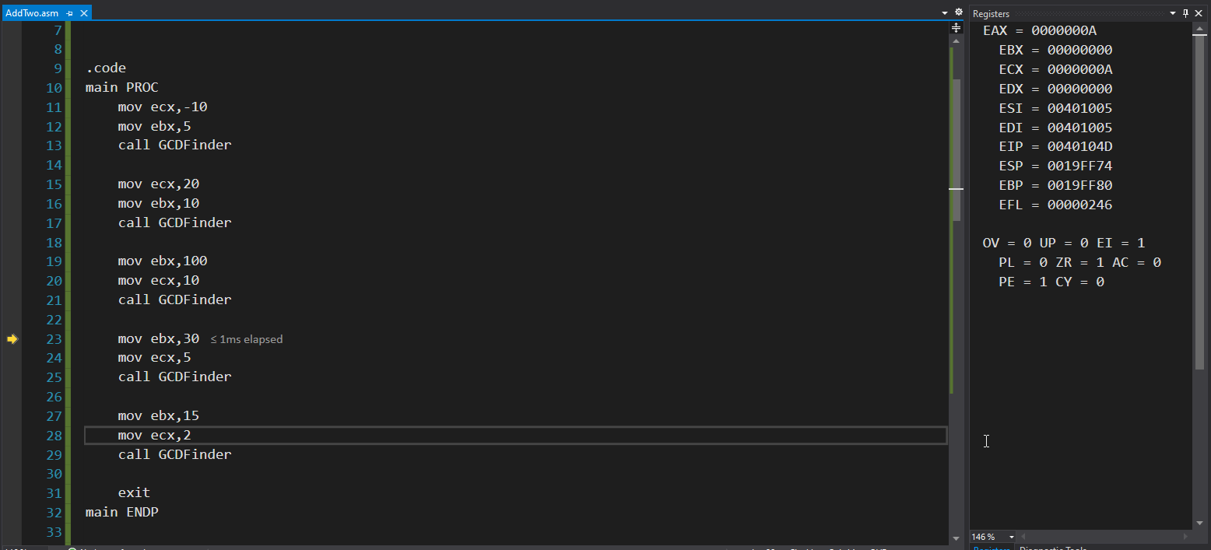

CONTINUED ON NEXT PAGE

RotEncrypt.asm Has the Encryption Using Rotate Operations programming excersize \*\*